Day 4: Azure IoT Suit

* Azure Event Hubs
* Azure Storage
* Azure Stream Analytics
* Microsoft Power BI
* IoT Security consideration

Azure Event Hubs

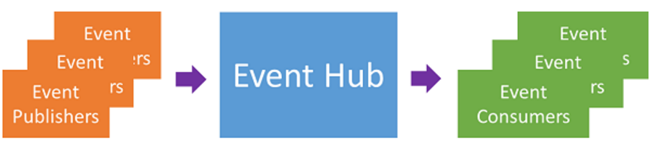

* is a managed platform service
* provides a foundation for large-scale data intake
  + mobile apps traffic information from web farms
  + in-game event capture in console games
  + telemetry data collected from industrial machines
  + connected vehicles.
* "front door" event ingestor.

Partitions

* A partition is an ordered sequence of events that is held in an Event Hub.
* As newer events arrive, they are added to the end of this sequence.
* A partition can be thought of as a "commit log."

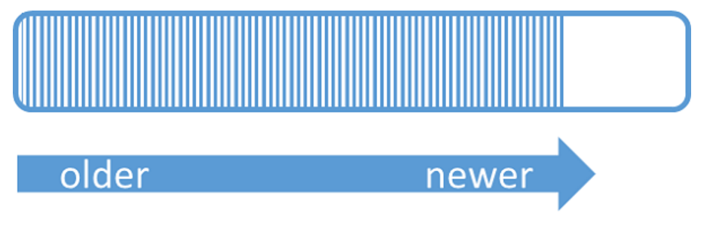

Event Hub / Partition

* Events expire on a time basis;
* you cannot explicitly delete them.
* An Event Hub contains multiple partitions.
* Each partition is independent and contains its own sequence of data.
* As a result, partitions often grow at different rates.

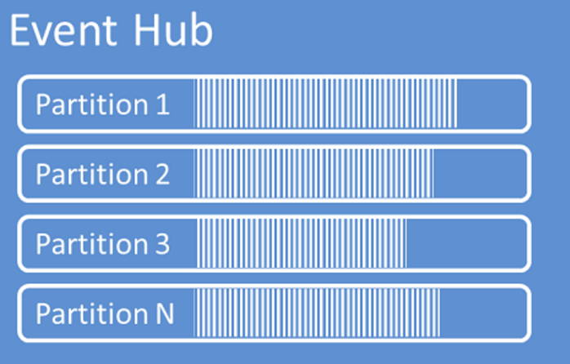

Azure Storage

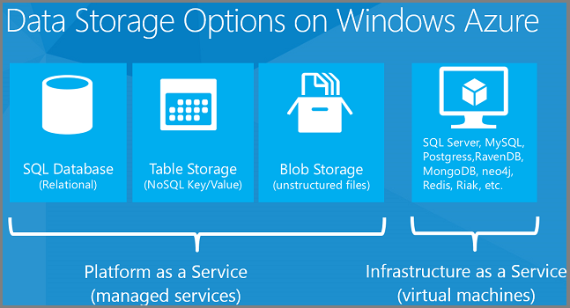

Azure Storage features

* 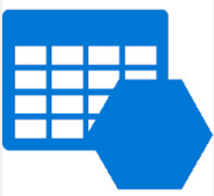Highly available
* Large-scale applications
* Storage foundation for Azure Virtual Machines
* Massively scalable
* Support the big data
* Support small business website
* Handles millions of requests per second
* Elastic, in terms of the amount of data stored and the number of request
* You pay only for what you use, and only when you use it.
* Automatically load-balances
* Accessible from anywhere in the world
* Supports Windows and Linux
* Support .NET, Java, Node.js, Python, Ruby, PHP and C++ and mobile programming languages)

Azure Table Service

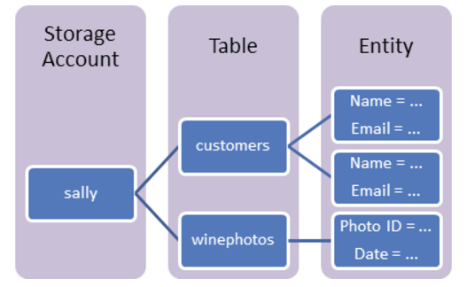

* Large amounts of structured data
* NoSQL
* Accepts authenticated calls from inside and outside the Azure cloud
* Non-relational data
* Storing TBs of structured data
* Storing datasets that don't require complex joins, foreign keys, or stored procedures
* LINQ queries

Azure Stream Analytics



* Perform real-time analytics for your Internet of Things solutions
* Stream millions of events per second
* Get mission-critical reliability and performance with predictable results
* Create real-time dashboards and alerts over data from devices and applications
* Correlate across multiple streams of data
* Use familiar SQL-based language for rapid development

In this session

1. Create Temperature sensing device
2. Sending telemetry data to Azure IoT Hub
3. Send data to Azure Stream Analytics
4. Sink event to BI
5. Create data visualization in Microsoft Power BI

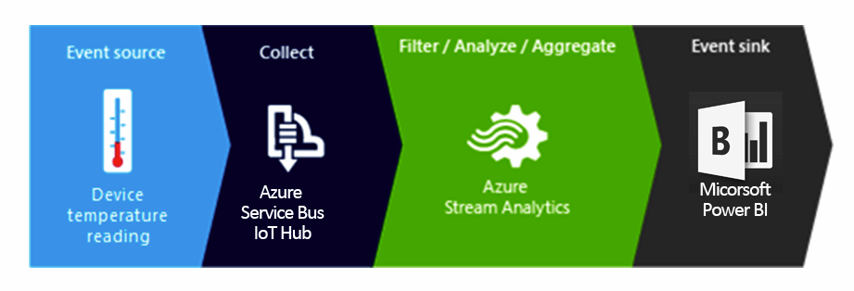

Sending telemetry data from device to Cloud

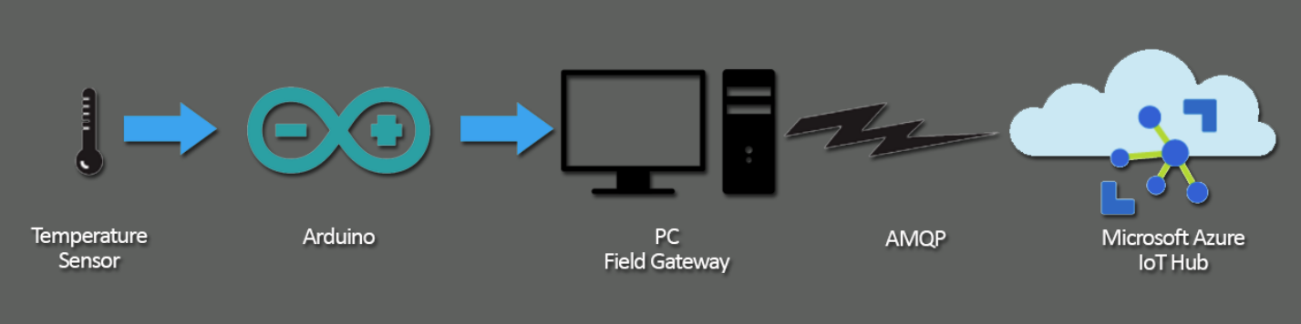

1. Make temperature circuit
2. Run Arduino Code and test
3. Run WinApp and test with Device Explorer

Make temperature circuit

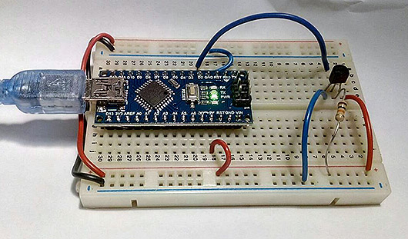

Run Arduino Code and test

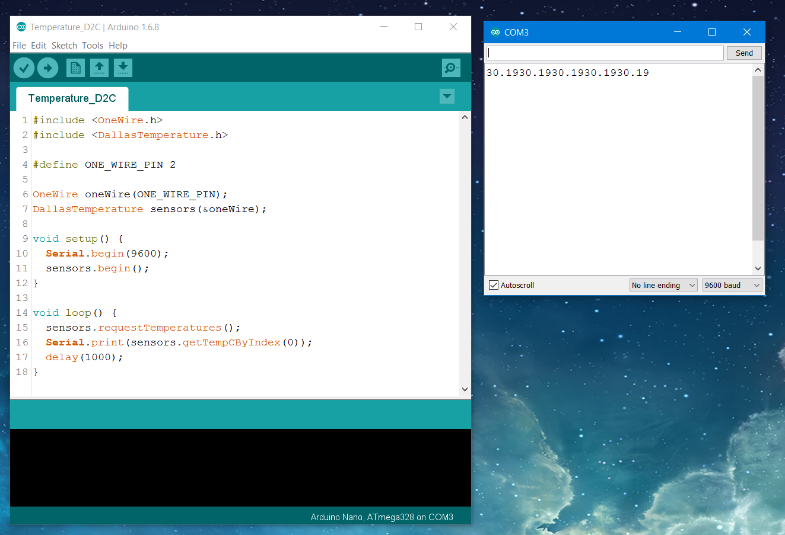

Run WinApp and test with Device Explorer

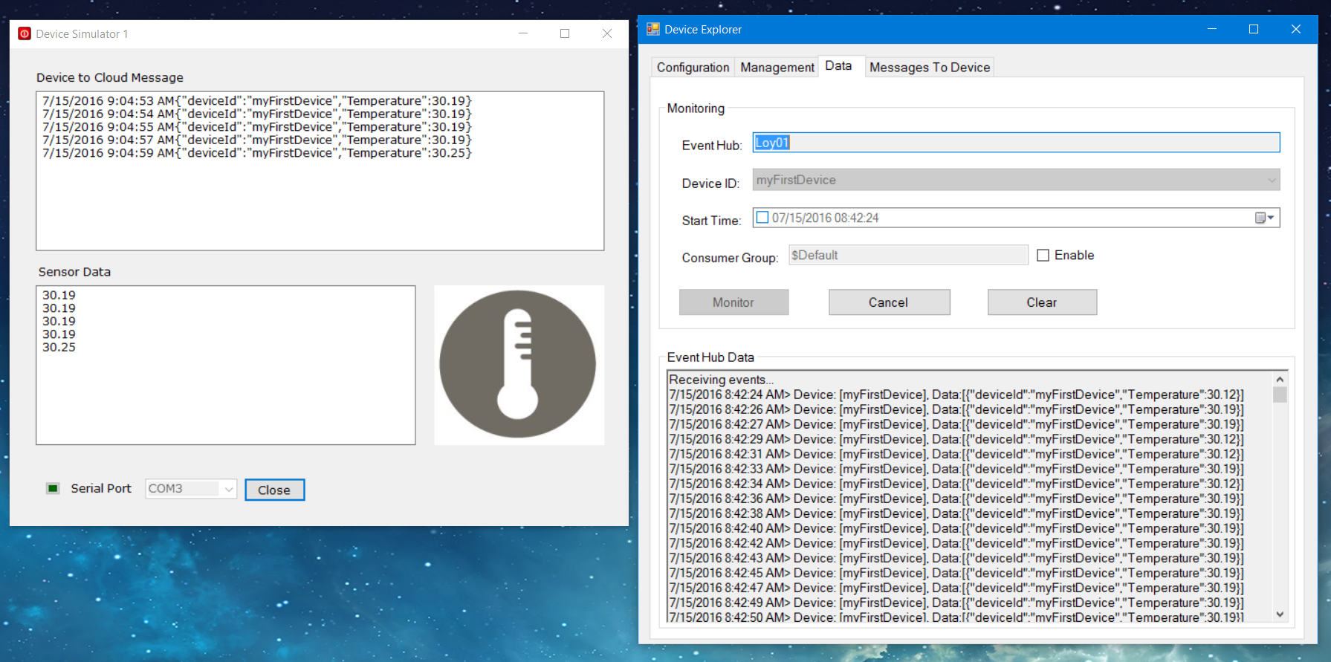

Create Azure Stream Analytics Job

1. Open Azure Dashboard
2. Create New Stream Analytics Job
3. Setup Input
4. Setup Output
5. Write query

Go to Azure Dashboard

https://portal.azure.com/

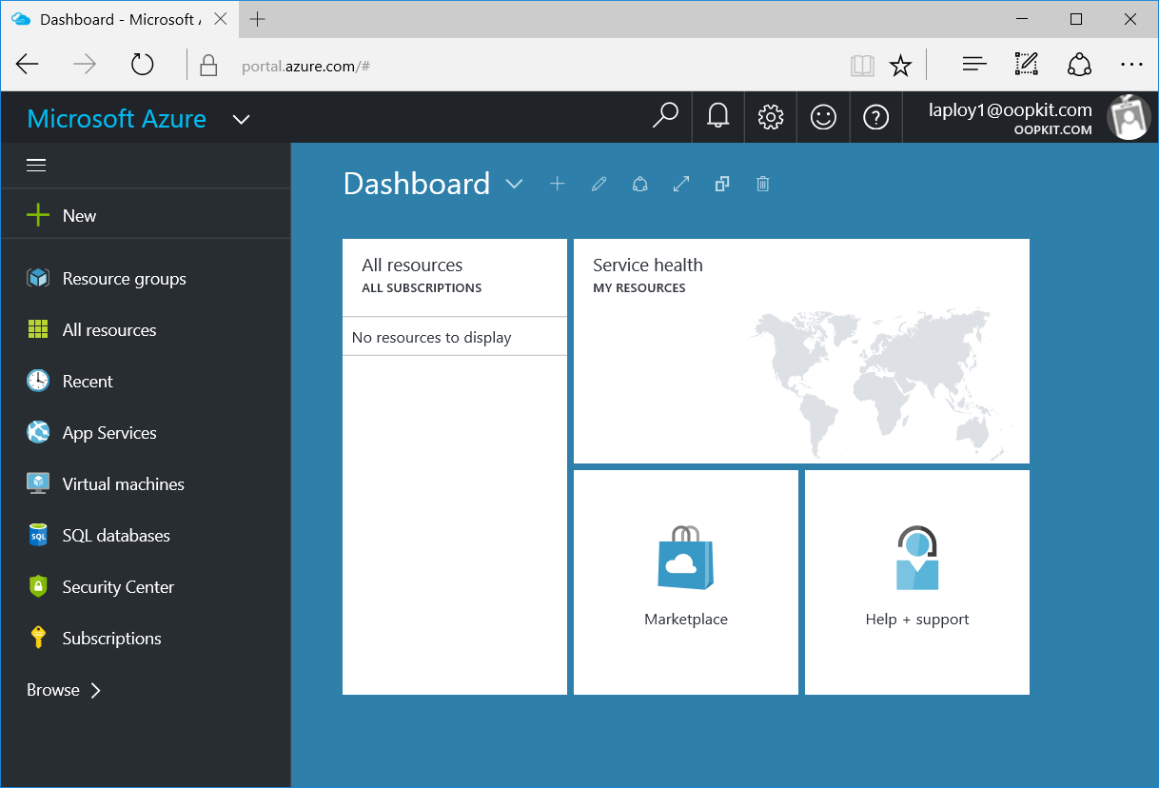

Create new Stream Analytics Job

New / Internet of Things / Stream Analytics Job

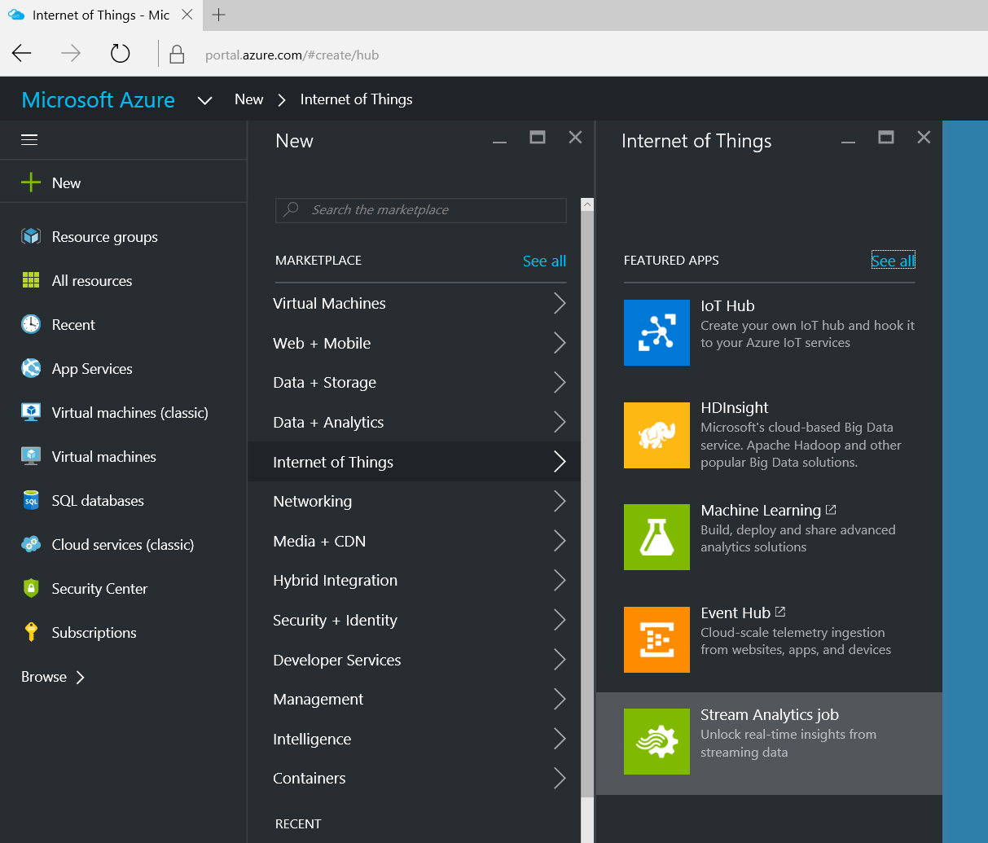

Create New Stream Analytics Job

Provide name / Resource group / location

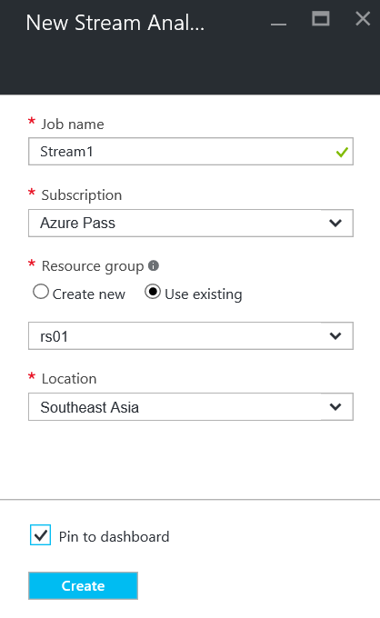

Wait for Stream1 to be created

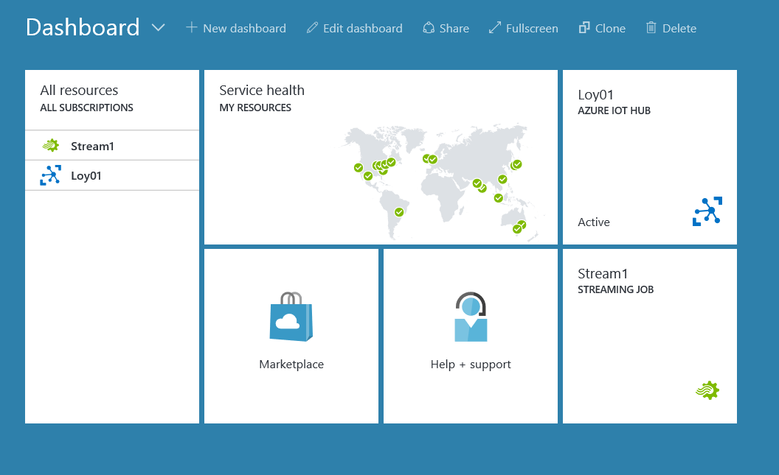

Create Stream Analytics Job Input

Open Stream1

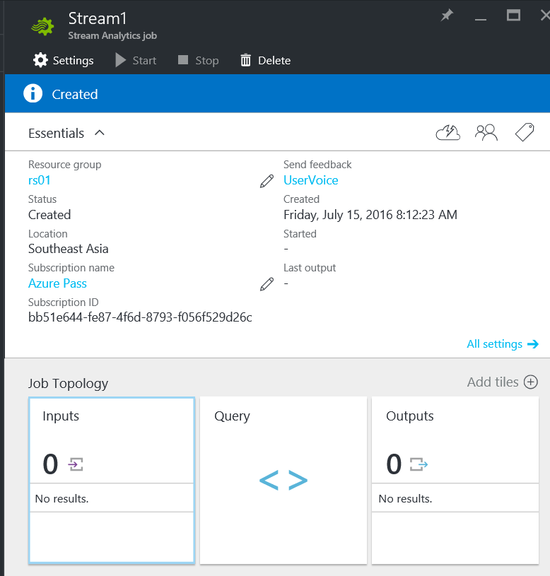

Input / + Add

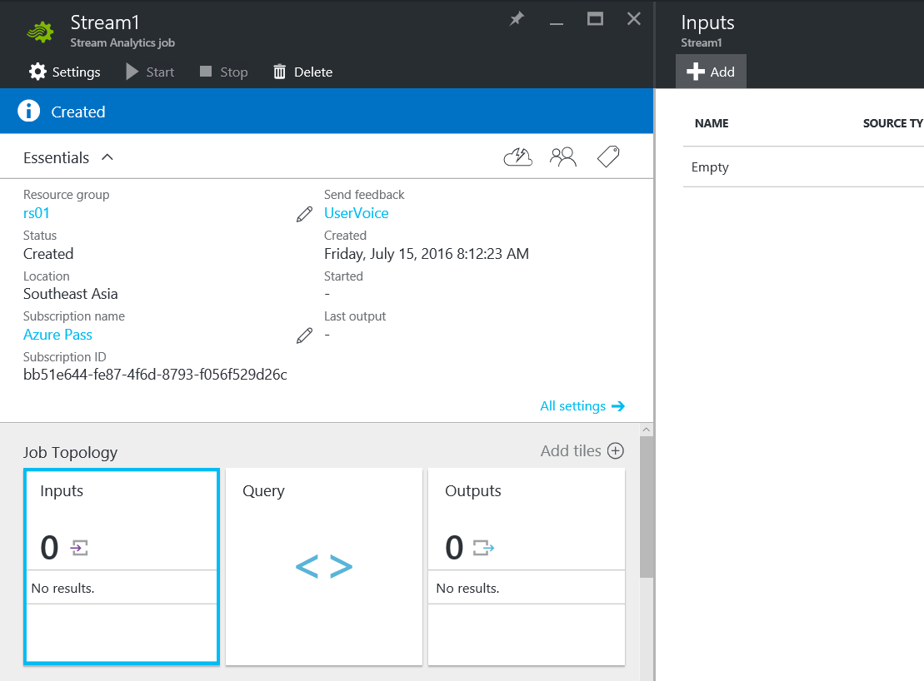

Set alias / source

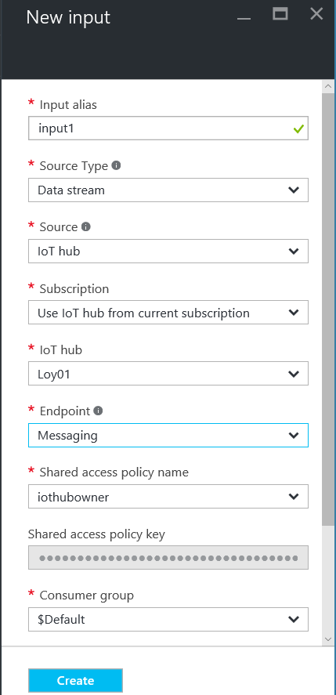

Wait for input1 to be created

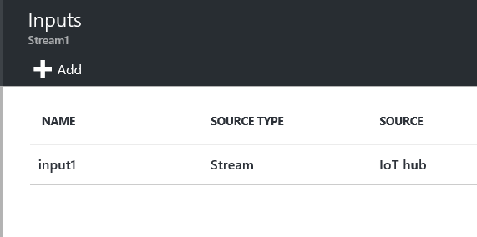

Clear Consumer group name

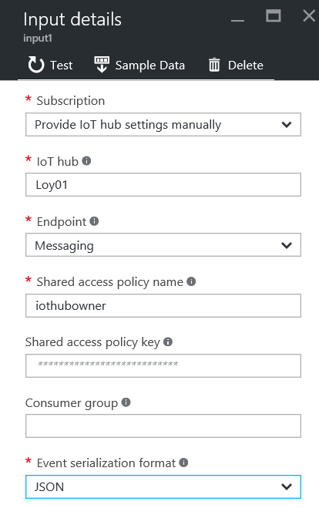

Click “Test” button to test connection

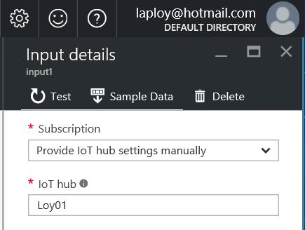

In Sample Data box, click “OK”

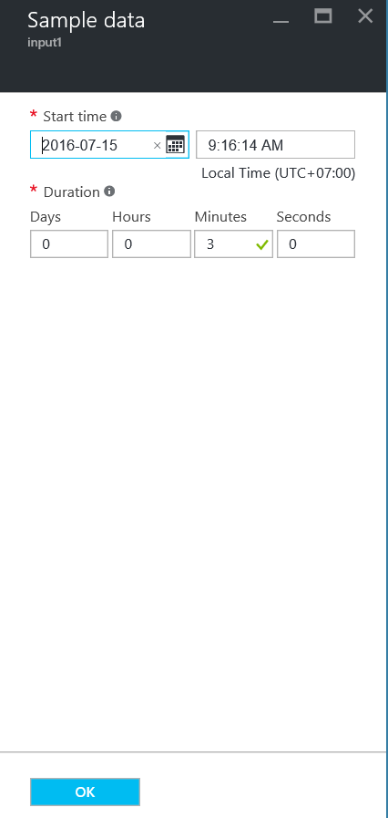

Look for “Successful connection test” message

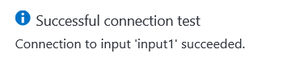

Down load sample data

Click the message

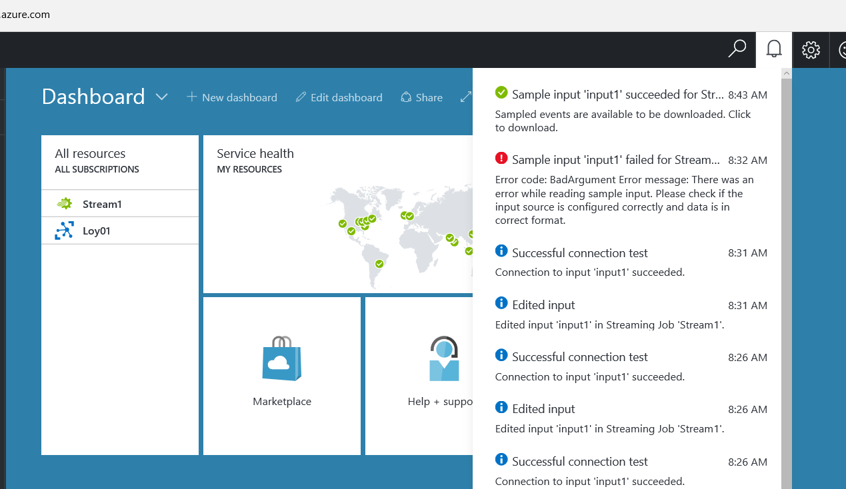

In sample data pane, click download button

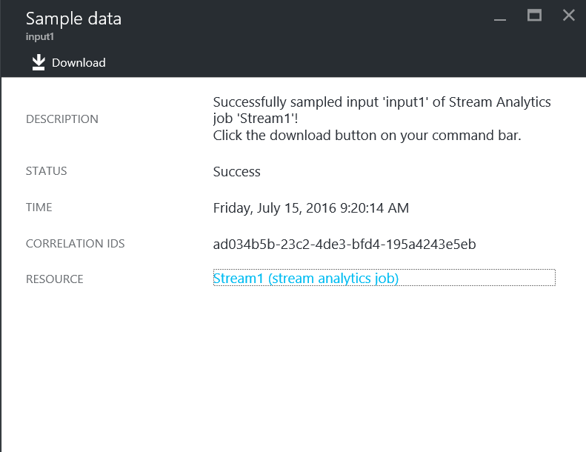

View Sample data in Text Editor

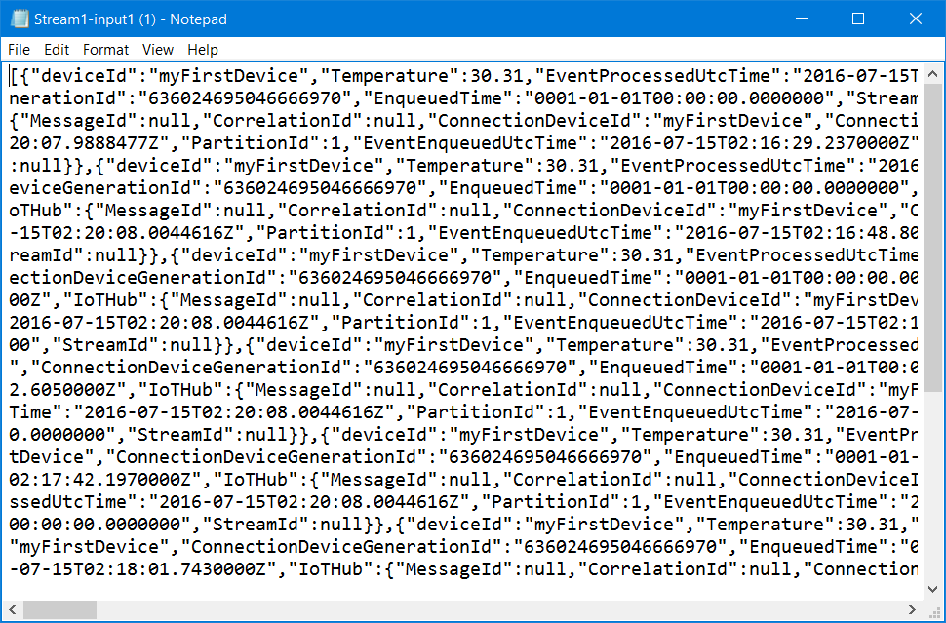

JSON message Analytics

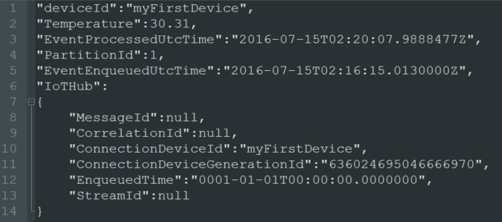

More on IoT hub message

* https://azure.microsoft.com/en-us/documentation/articles/iot-hub-csharp-csharp-process-d2c/
* https://azure.microsoft.com/en-us/documentation/articles/iot-hub-devguide/
* https://azure.microsoft.com/en-us/documentation/articles/event-hubs-overview

Create Stream Analytics Job Output

Click Output

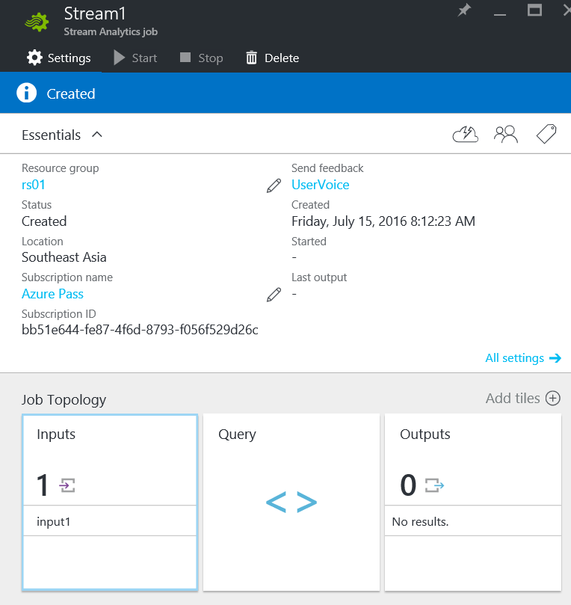

Click +Add

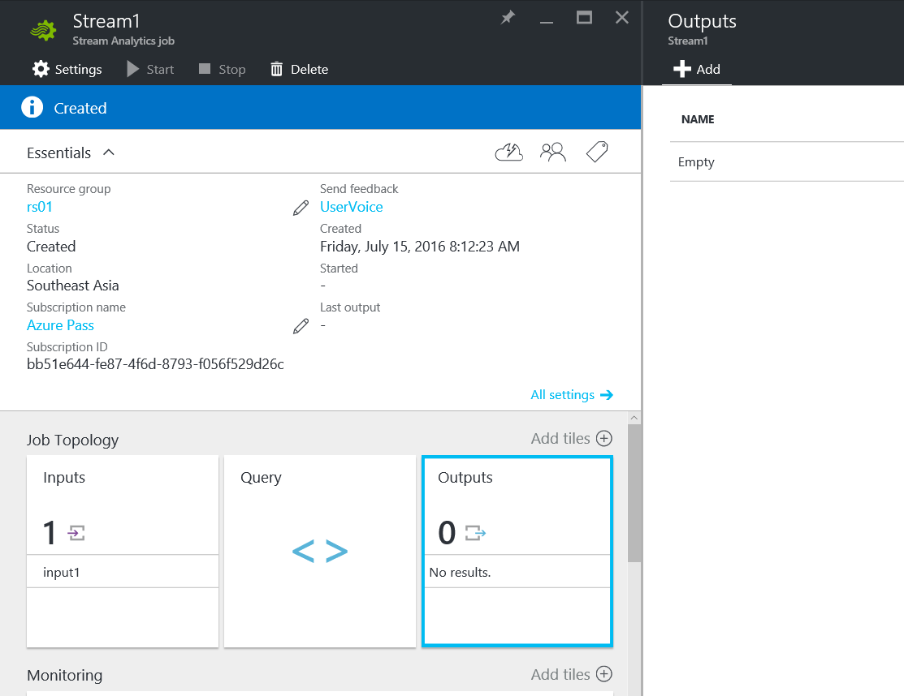

Set Output alias / Sink Power BI / Authorize

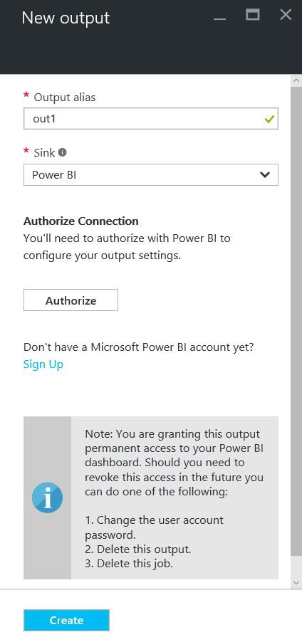

Provide Power BI credential

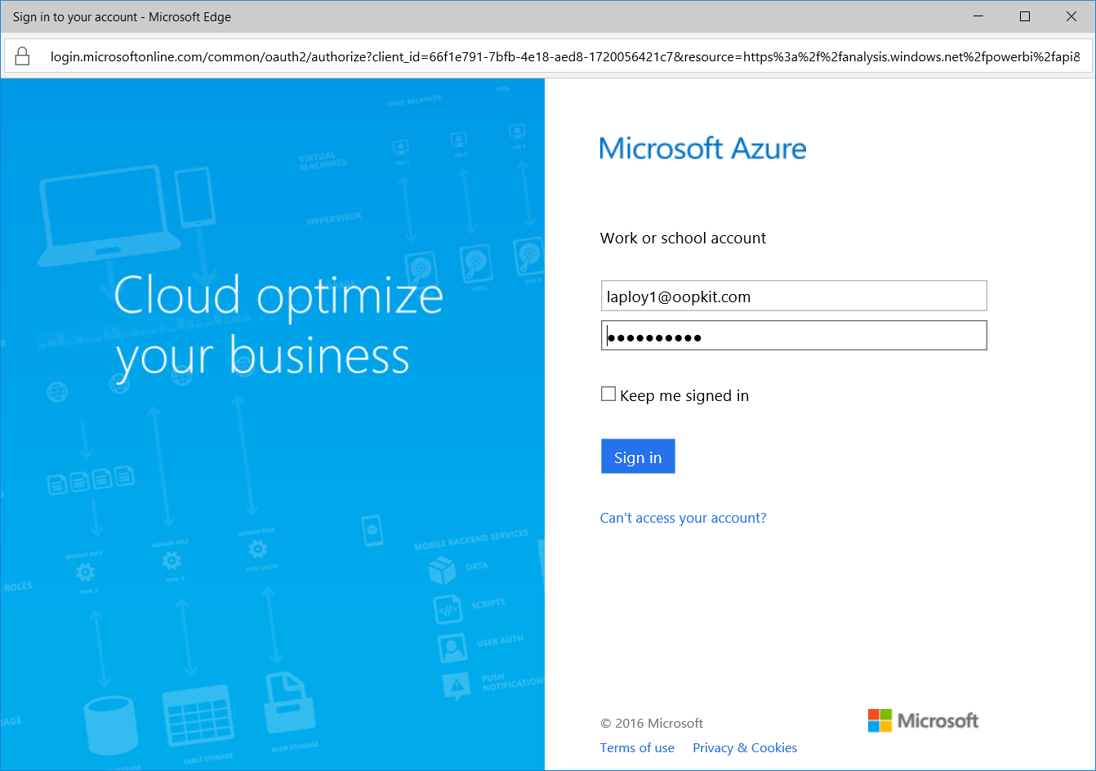

Enter Dataset Name / Table Name / Create

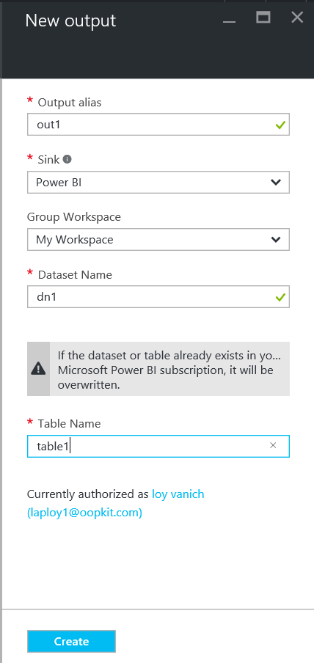

Look for Successful message

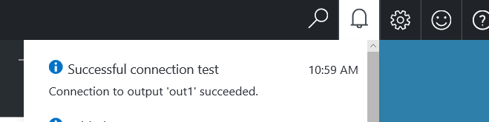

Create Stream Analytics Job query

Click Query

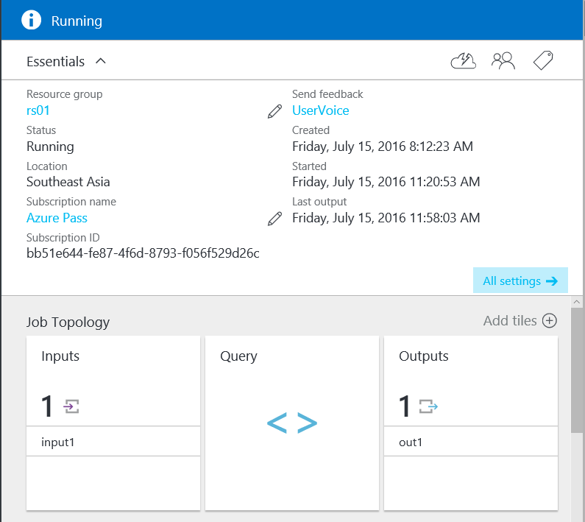

Enter the Query and save

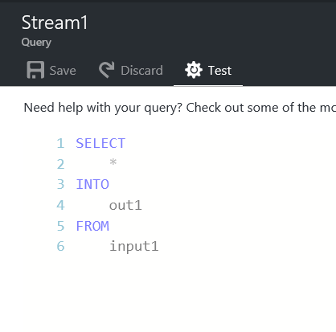

What is Microsoft Power BI?

* Share with anyone
* Simple and fast
* Robust and enterprise-grade
* Real-time analytics
* A collection of software services, apps, and connectors
* Turn unrelated sources of data into interactive insights.
* Easily connect to data sources
* Visualize

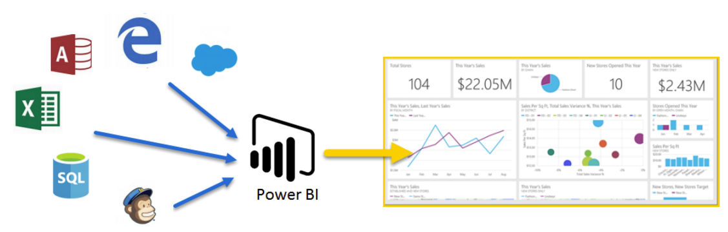

Create simple IoT data visualization in Power BI

Go to Microsoft Power BI page https://powerbi.microsoft.com/en-us/

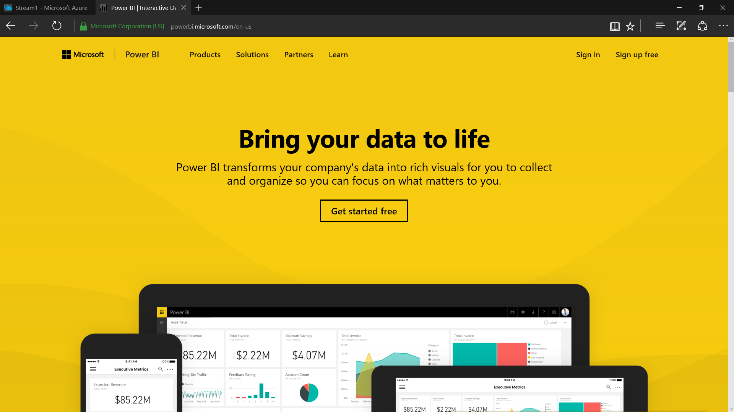

Click menu button to show Jumpbar

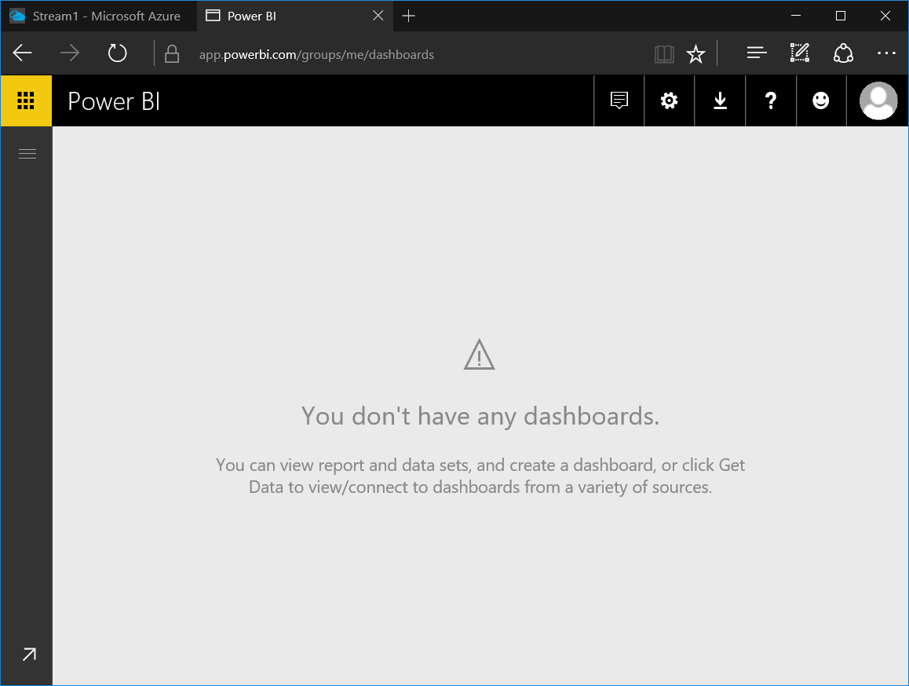

Note the Dataset

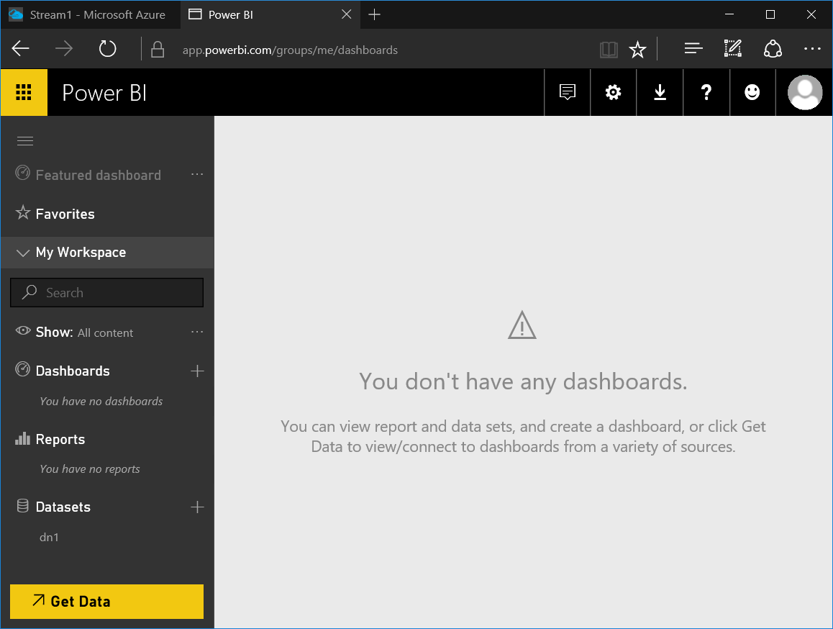

Create new Dashboard

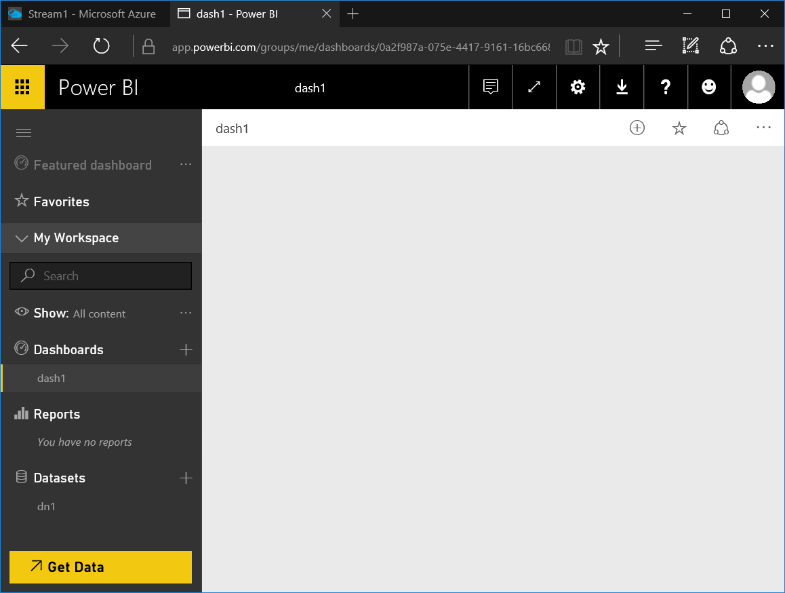

Click Dataset Name

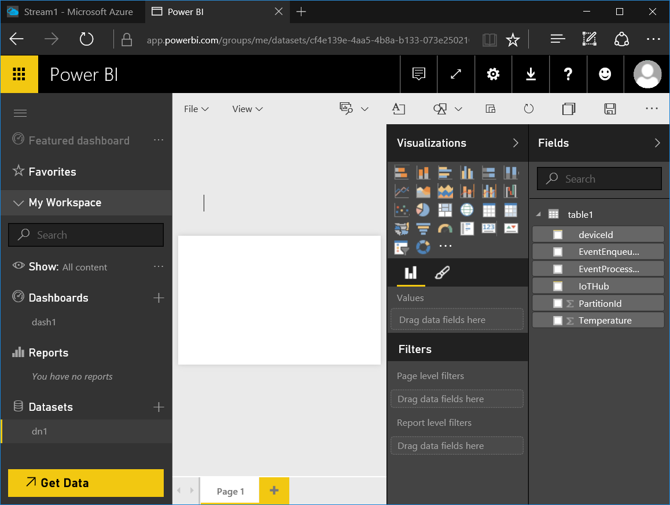

Select Area chart

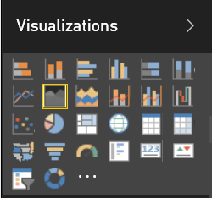

Set Axis / Value

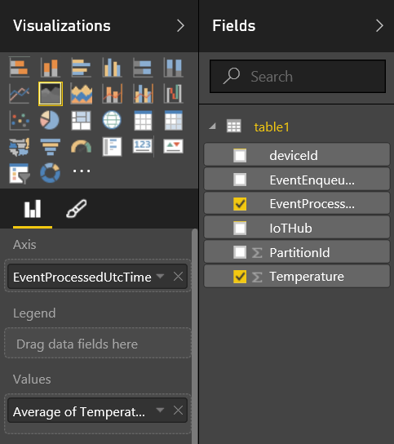

Adjust chart size and pin to Dashboard

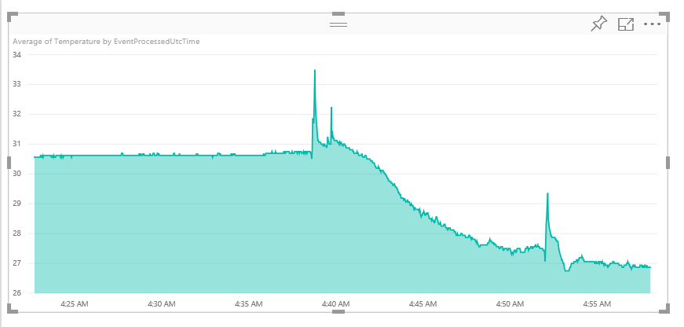

Specify report name and save

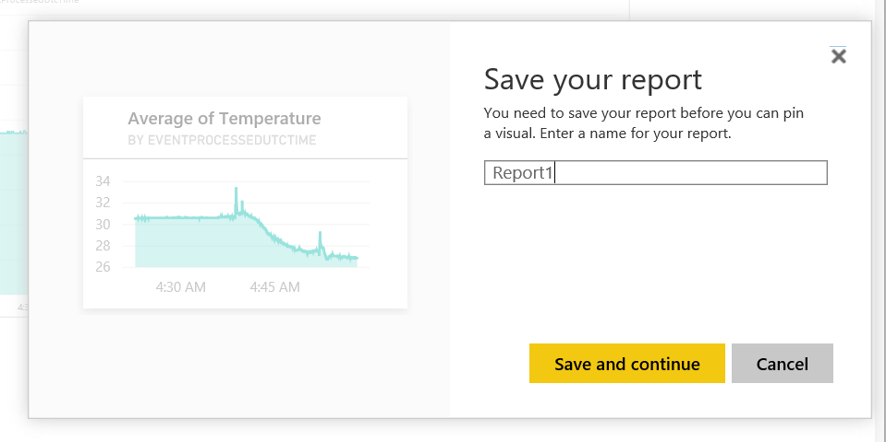

Select dashboard to pin

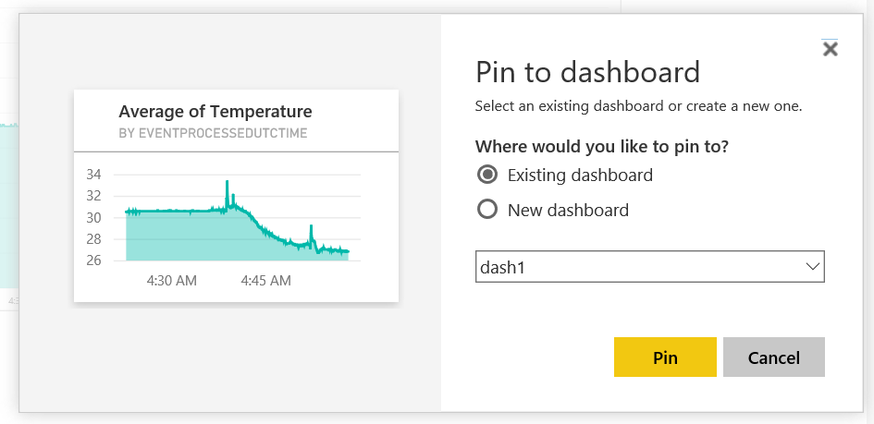

View dashboard

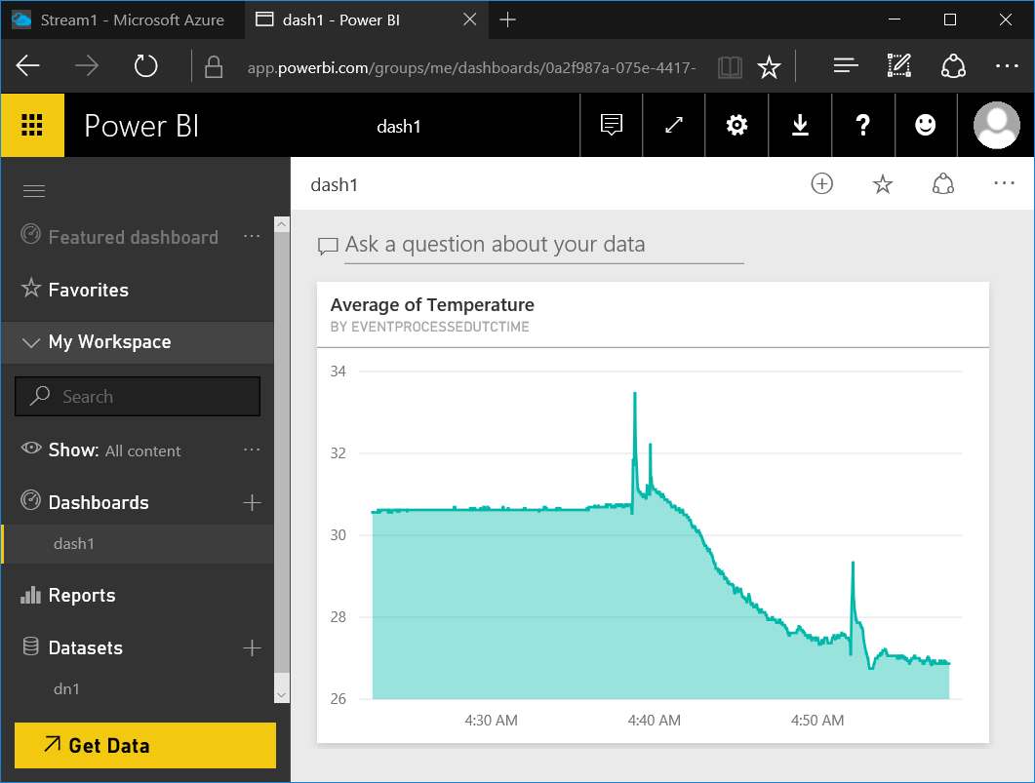

More on Stream Data Analytics

* https://powerbi.microsoft.com/en-us/guided-learning/
* https://azure.microsoft.com/en-us/services/stream-analytics/
* https://azure.microsoft.com/en-us/documentation/articles/stream-analytics-power-bi-dashboard/
* https://azure.microsoft.com/en-us/documentation/articles/iot-hub-csharp-csharp-process-d2c/

IoT Security consideration

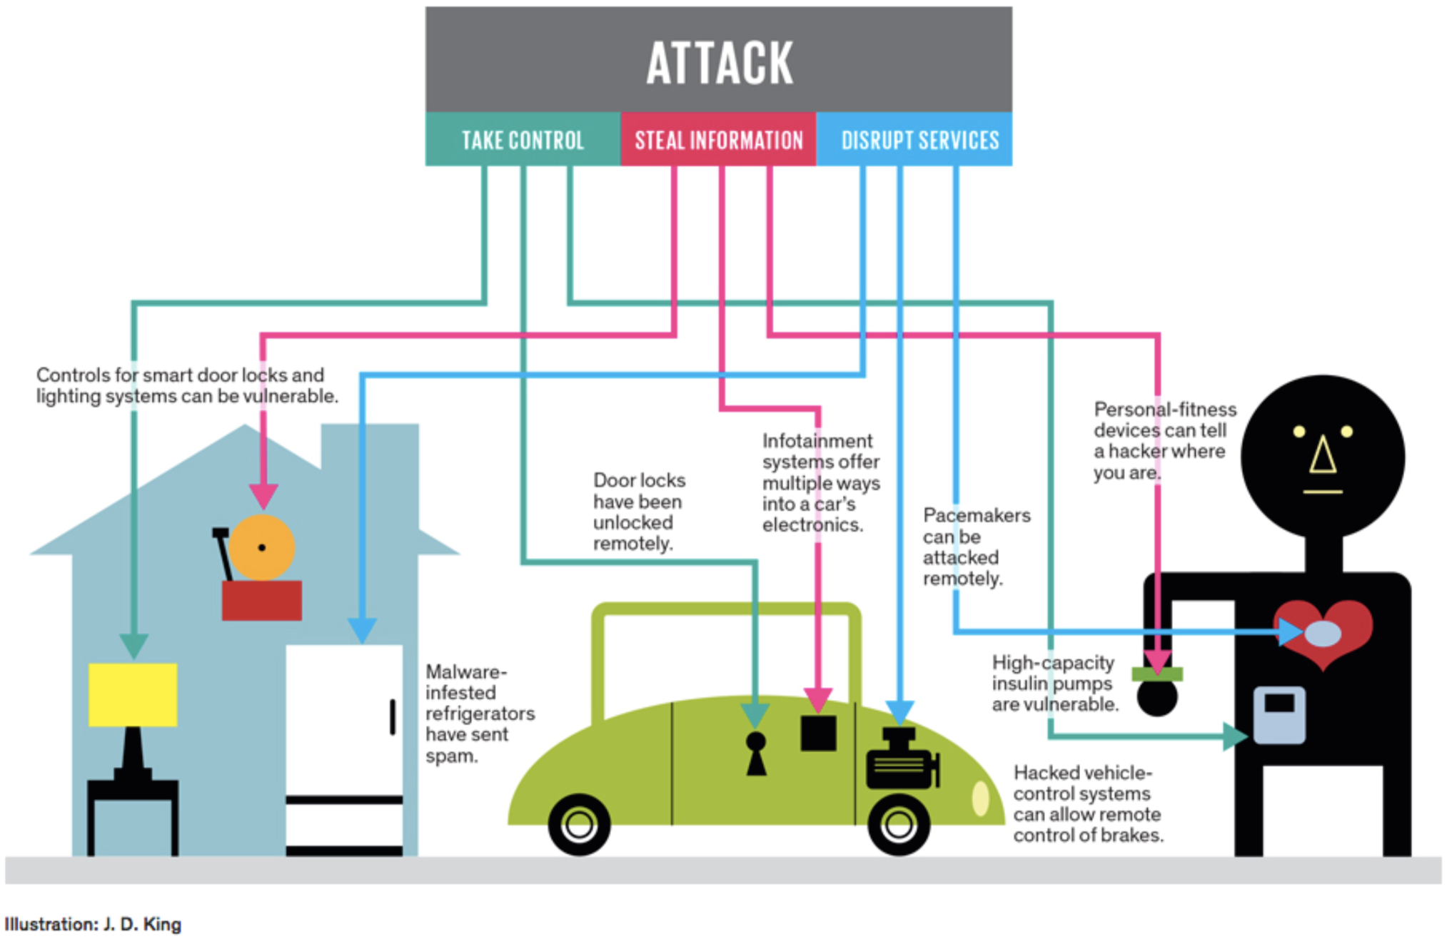

IoT Attack area

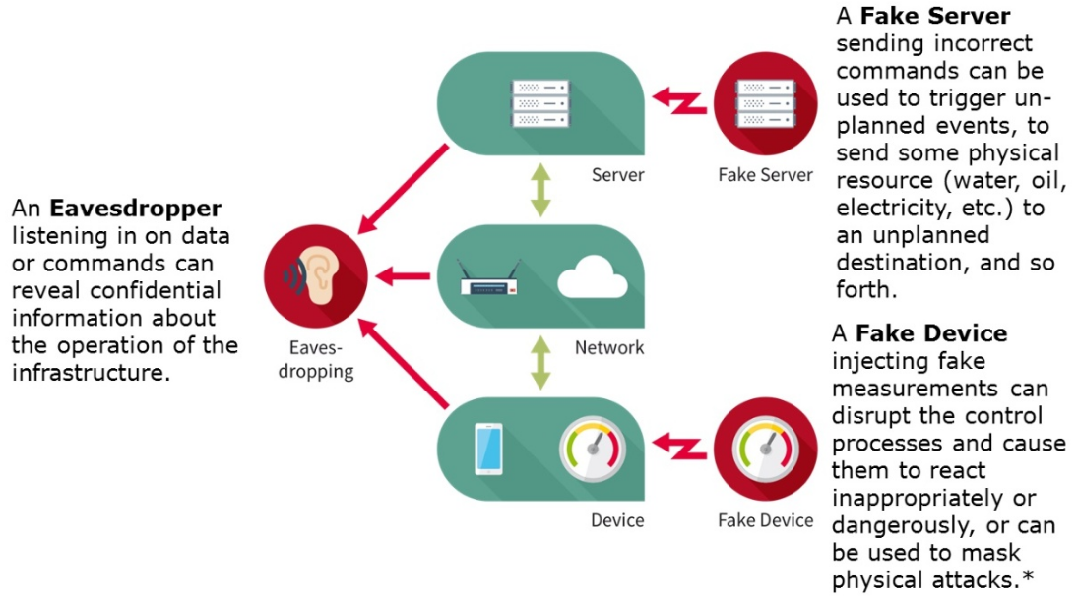

Azure IoT Suite security features

